TexLa Project ECHO - FY 2027

TexLa Project ECHO - FY 2027 - 10/15/2026
October 15, 2026
12:00 PM - 1:00 PM
Texas Tech University Health Sciences Center at Lubbock

Overview:
TexLa Project ECHO is an interprofessional educational series designed to strengthen the healthcare teams knowledge and application of telemedicine best practices across clinical specialties. Sessions address patient selection, workflow integration, technology utilization, ethical considerations, patient access, care coordination, and evidence-based virtual care strategies to improve clinical decision-making, patient safety, and quality of care.

Learning Objectives:
1 Apply evidencebased telehealth best practices across clinical specialties to support safe, effective, and patientcentered virtual care.
2 Integrate telehealth strategies related to patient selection, workflow, technology use, and care coordination into clinical practice.
3 Collaborate across professions to address telehealth challenges and improve communication, access, patient safety, and quality of care.

Target Audience:
Professions: Physician, PhD (Researcher/Faculty), Student, Nurse, Allied Health Professional, Educator, Physician Resident, Physician (Researcher)
Accreditation Statement:
 | In support of improving patient care, Texas Tech University Health Sciences Center (TTUHSC) is jointly accredited by the Accreditation Council for Continuing Medical Education (ACCME), the Accreditation Council for Pharmacy Education (ACPE), and the American Nurses Credentialing Center (ANCC), to provide continuing education for the healthcare team.

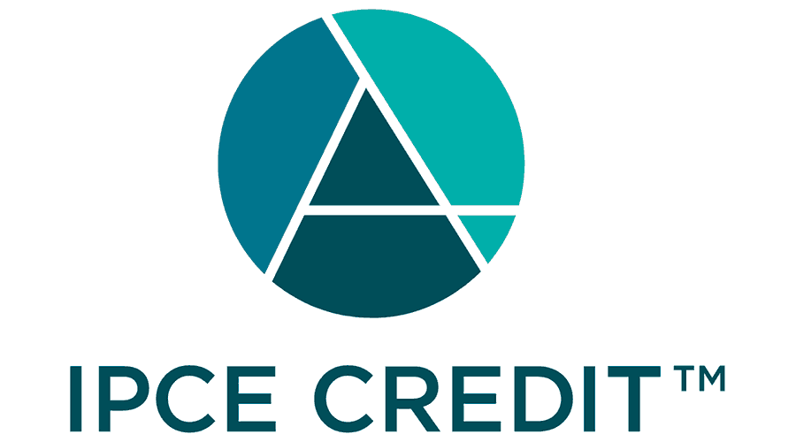 | This activity was planned by and for the healthcare team, and learners will receive 1.00 Interprofessional Continuing Education (IPCE) credits for learning and change.

Credit Designation Statements:

Texas Tech University Health Sciences Center (TTUHSC) designates this Live Activity for a maximum of 1.00 AMA PRA Category 1 Credit(s)™. Physicians should claim only the credit commensurate with the extent of their participation in the activity.

ANCC:
Texas Tech University Health Sciences Center (TTUHSC) designates this activity for 1.00 Nursing contact hours. Nurses should only claim credit commensurate with the extent of their participation in the activity.

















Mitigation of Relevant Financial Relationships:
Texas Tech University Health Sciences Center adheres to the ACCME Standards for Integrity and Independence in Accredited Continuing Education. Individuals in a position to control the content of a CE activity, including faculty, planners, reviewers, and others, are required to disclose all financial relationships with ineligible companies within the past 24 months. TTUHSC reviews these relationships to determine whether they are relevant to the educational content. Any relevant financial relationships are mitigated prior to the commencement of the activity, and relevant financial relationships and their mitigation are disclosed to learners.
Name of individual | Individual's role in activity | Nature of Relationship(s) / Name of Ineligible Company(s)
Kelly Alvarez, Other | Course Director | Nothing to disclose - 08/12/2026
Karla A Daniele, MD | Faculty | Nothing to disclose - 09/10/2026
Rachel Flores, CHWI | Activity Administrator, Activity Coordinator | Nothing to disclose - 08/05/2026
Edgar Fuentes, CHWI, | Other Planning Committee Member | Nothing to disclose - 06/05/2026
Cynthia Ogaz, DBA, MBA, CHCP | Other Planning Committee Member | Nothing to disclose - 06/15/2026
Brandel Quiros, CHW | Activity Coordinator | Nothing to disclose - 09/22/2026
Ariel P Santos, MD, MPH | Course Director | Nothing to disclose - 10/09/2026

Commercial Support:

No commercial support has influenced the planning, implementation, or evaluation of the content of this activity.

CLOUDCME LEARNER SETUP AND ATTENDANCE
Use the TTUHSC CloudCME portal and mobile app to manage CE activities, complete evaluations, claim credit, and access certificates and transcripts.
Portal: https://ttuhsc.cloud-cme.com
Mobile app organization code: TTUHSC
Before the Activity
1. Create or confirm your CloudCME account at the TTUHSC CloudCME portal.
2. Complete your profile. Required fields are marked with an asterisk. Select your Degree and Profession so the appropriate credit type is available.
3. Pair your cell phone for SMS attendance. This is a one-time setup. From your mobile phone, text the email address used to log in to CloudCME to (833) 725-8040.
4. Save the SMS number as TTUHSC CloudCME for future activities.

During the Activity
1. Record attendance by texting the Activity ID number provided for the activity to (833) 725-8040.
2. Attendance can be recorded 60 minutes before the activity, during the activity, or up to 24 hours after the activity.
3. A confirmation text will verify that your attendance has been recorded. If you do not receive confirmation, contact TTUHSC OPDACE for assistance.

Mobile App Option
1. Download the CloudCME mobile app, open the app, and use organization code TTUHSC.
2. Log in with your CloudCME email address and password. The app menu may include My Evaluations, My Certificates, My Transcript, Calendar, Scan Attendance, and Claim Credit, depending on the activity and institutional settings.
Apple iOS: https://itunes.apple.com/us/app/cloudcme/id624053130?mt=8
Google Android: https://play.google.com/store/apps/details?id=com.healthstream.cloudcme

INSTRUCTIONS ON HOW TO RECEIVE CREDIT
To receive credit, attendees must complete all required activity steps in CloudCME.
- Confirm attendance using the activity-specific attendance method. If SMS attendance is used, text the Activity ID number to (833) 725-8040.
OR
- If app was used scan attendance QR code provided:

ADD QRCODE HERE

2. Complete the activity evaluation in CloudCME. Certificates are generated after the required evaluation and credit steps are completed.
a. Via the TTUHSC CloudCME portal: go to https://ttuhsc.cloud-cme.com, sign in, select My CME or My CE, then select Evaluations & Certificates. Locate the activity, complete the evaluation, and download or email your certificate.
b. Via the CloudCME mobile app: open the app, use organization code TTUHSC, log in, select My Evaluations, complete the evaluation, and access your certificate through My Certificates.
3. Claim only the credit commensurate with the extent of your participation in the activity.
4. Contact TTUHSC OPDACE at OPDACE@ttuhsc.edu or 806-743-2929 if you have trouble accessing CloudCME, recording attendance, completing the evaluation, or downloading your certificate.
5. Speakers/presenters cannot claim credit for their own presentations.

Reminders
• Evaluation and credit claim deadline: [DATE/TIME].
• Activities that use SMS attendance require a one-time phone pairing with your CloudCME account before texting the Activity ID.
• Pharmacists and pharmacy technicians must confirm that their NABP e-Profile ID and date of birth are accurate in their CloudCME profile so credit can be reported to NABP CPE Monitor.

Transcripts Request Information
The Office of Professional Development and Accredited Continuing Education maintains transcripts of credits earned by learners for live activities certified by Texas Tech University Health Sciences Center.
• CloudCME portal: select My CME or My CE, then Transcript to view, download, or email your transcript.
• CloudCME mobile app: select My Transcript to view, print, or email your transcript, if available.
• For assistance with CloudCME, contact the CPD Office at 806-743-2929.
• To request a transcript in writing, send your name, address, and the requested time period to TTUHSC - Office of Professional Development and Accredited Continuing Education, 3601 4th Street STOP 7113, Lubbock, Texas 79430-7113.

