Documenting What Matters: A Team-Based Approach to Advanced Practice Practitioner Collaboration, Billing, and Epic Documentation

September 24, 2026
4:30 PM - 6:00 PM
Texas Tech University Health Sciences Center at Lubbock

Overview:
This live, two-hour training is designed for the interprofessional team involved in patient care documentation, coding, billing, compliance, and clinical operations, including physicians, advanced practice practitioners, coders, billing staff, compliance staff, and clinic leaders. Each member of the team plays an important role in ensuring that documentation accurately reflects the care provided and supports appropriate billing. Using a team-based approach, the activity will address how physicians and advanced practice practitioners work together in clinical care and documentation, how coders and billing staff use documentation to support accurate level of service selection, and how the entire team can reduce compliance risk related to incomplete, copied, cloned, or unsupported notes. The first hour will focus on team roles in physician and advanced practice practitioner collaboration, documentation of each providers contribution, medical necessity, level of service selection, procedure documentation, and common compliance concerns. The second hour will focus on how the team can use Epic documentation tools and features, including SmartPhrases, SmartText, SmartLinks, SmartLists, templates, and available Epic training resources, to support complete, accurate, and patient-specific documentation. Through case examples and practical discussion, participants will examine how documentation affects patient care, coding, billing workflows, compliance review, reimbursement, and communication across the care team. This activity is intended to strengthen team-based collaboration, improve documentation quality, support compliant billing practices, and promote effective use of Epic following the institutions transition to Epic for patient care and billing services.

Learning Objectives:
1 Identify at least three documentation, coding, billing, compliance, or Epic requirements that support accurate teambased documentation of physician and advanced practice practitioner collaboration, level of service selection, medical necessity, and procedure documentation.
2 Apply teambased documentation strategies during case discussions to clarify each team members contribution, support medical necessity, select the appropriate level of service, document procedures accurately, respond to coder feedback, and use Epic tools appropriately.
3 Implement at least one teambased documentation improvement in practice to reduce copied or cloned notes, improve providercoder communication, support compliant billing, and strengthen patientspecific documentation in Epic.

Target Audience:
Specialties: Emergency Medicine, Internal Medicine, Oncology, Nursing, Allied Health Professions, Behavioral And Mental Health, Cardiology, Family Medicine, Pharmacy, Population And Public Health, Surgery
Professions: Non-Physician, Nurse Practitioner, PhD (Researcher/Faculty), Physician Assistant, Nurse, Allied Health Professional
Accreditation Statement:
 | In support of improving patient care, Texas Tech University Health Sciences Center (TTUHSC) Office of Professional Development and Accredited Continuing Education (OPDACE) is jointly accredited by the Accreditation Council for Continuing Medical Education (ACCME), the Accreditation Council for Pharmacy Education (ACPE), and the American Nurses Credentialing Center (ANCC), to provide continuing education for the healthcare team.

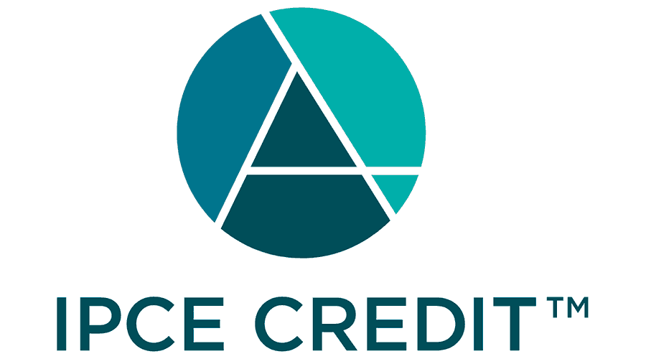 | This activity was planned by and for the healthcare team, and learners will receive 1.50 Interprofessional Continuing Education (IPCE) credits for learning and change.

Credit Designation Statements:

Texas Tech University Health Sciences Center (TTUHSC) Office of Professional Development and Accredited Continuing Education (OPDACE) designates this Live Activity for a maximum of 1.50 AMA PRA Category 1 Credit(s)™. Physicians should claim only the credit commensurate with the extent of their participation in the activity.

ANCC:
Texas Tech University Health Sciences Center (TTUHSC) Office of Professional Development and Accredited Continuing Education (OPDACE) designates this activity for 1.50 Nursing contact hours. Nurses should only claim credit commensurate with the extent of their participation in the activity.







AAPA – Live:
Texas Tech University Health Sciences Center (TTUHSC) Office of Professional Development and Accredited Continuing Education (OPDACE) has been authorized by the American Academy of PAs (AAPA) to award AAPA Category 1 CME credit for activities planned in accordance with AAPA CME Criteria. This activity is designated for 1.50 AAPA Category 1 CME credits. PAs should only claim credit commensurate with the extent of their participation.







Medical Ethics

This activity has been reviewed by the TTUHSC Office of CME and provides 1.50 hour(s) of formal CME in Medical Ethics and/or Professional Responsibility.





Mitigation of Relevant Financial Relationships:
Texas Tech University Health Sciences Center adheres to the ACCME Standards for Integrity and Independence in Accredited Continuing Education. Individuals in a position to control the content of a CE activity, including faculty, planners, reviewers, and others, are required to disclose all financial relationships with ineligible companies within the past 24 months. TTUHSC reviews these relationships to determine whether they are relevant to the educational content. Any relevant financial relationships are mitigated prior to the commencement of the activity, and relevant financial relationships and their mitigation are disclosed to learners.
Name of individual | Individual's role in activity | Nature of Relationship(s) / Name of Ineligible Company(s)
Allan Haynes, Jr Jr., MD | Other Planning Committee Member | Nothing to disclose - 07/09/2026
Anna M. M McGregor, Bachelors | Course Director, Faculty | Nothing to disclose - 07/08/2026
Cynthia Ogaz, DBA, MBA, CHCP | Other Planning Committee Member | Nothing to disclose - 06/15/2026
Brandel Quiros, (None) | Activity Coordinator | Nothing to disclose - 06/01/2026
Milly Rodriquez, MD | Activity Coordinator | Nothing to disclose - 04/13/2026
Joel Sanchez, DNAP, CRNA | Nurse Planner | Nothing to disclose - 06/30/2026
Jolene S Turpin, BS | Other Planning Committee Member | Nothing to disclose - 06/09/2026
ShaBre' Wilson, (None) | Activity Coordinator | Nothing to disclose - 07/07/2026

Commercial Support:

No commercial support has influenced the planning, implementation, or evaluation of the content of this activity.

